Code and diagram model of Lucy café delivery system file.

---
# Lucy Cafe Food Delivery

## 🌟 Project Introduction
Lucy Cafe is a specialized food and drink delivery platform designed exclusively for the **Arba Minch University (AMU) Main Campus**. The system bridges the gap between the campus cafe and the university community, providing a seamless ordering experience for both students and staff.

The platform is tailored to the unique geography of the AMU campus, ensuring that food reaches students in their specific **Dorm Blocks** and instructors in their **Condominiums or Offices**. By integrating local digital payment solutions, the system eliminates the need for cash and speeds up the delivery process.

---

## 🛠️ Technical Features
* **Role-Based Access Control (RBAC):** Distinct interfaces and permissions for Students, Instructors, Drivers, and System Administrators.
* **Location-Specific Routing:** Automated destination tracking for AMU landmarks, including Dormitory Blocks, Faculty Condominiums, and Administrative Offices.
* **Business Logic Restrictions:** Built-in validation to enforce campus rules (e.g., Drink items are exclusive to Instructor accounts).
* **Digital Payment Integration:** Secure payment processing through **CBE Birr** and **Telebirr** APIs.
* **Real-Time Order Tracking:** A state-managed lifecycle that tracks orders from "Pending" through "AMU Main Gate" to "Delivered."

---
classDiagram
%% --- CLASSES FOR AMU CAMPUS ---
class User {
+int userID
+string name
+login()
}
class Admin {
+manageMenu()
+viewReports()
}
class Student {
+string dormNumber
+string block
}
class Instructor {
+string condoNumber
+string officeNumber
}
class Driver {
+string vehicleID
+bool isAvailable
+markDelivered()
}
class Order {
+int orderID
+string locationType
+bool hasDrinks
}
class FoodItem {
+string name
+float price
}
class DrinkItem {
+string type
+bool isAlcoholic
}
class Payment {
+int transactionID
+string provider
+processCBE()
+processTelebir()
}

%% --- RELATIONSHIPS ---
User <|-- Admin
User <|-- Student
User <|-- Instructor
User <|-- Driver
Student "1" -- "0..*" Order : orders_food_only
Instructor "1" -- "0..*" Order : orders_food_and_drinks
Order "1" *-- "1..*" FoodItem : includes
Order "1" *-- "0..*" DrinkItem : includes
Order "1" -- "1" Payment : via_CBE_Telebir
Driver "1" -- "0..*" Order : delivers_to_AMU
```

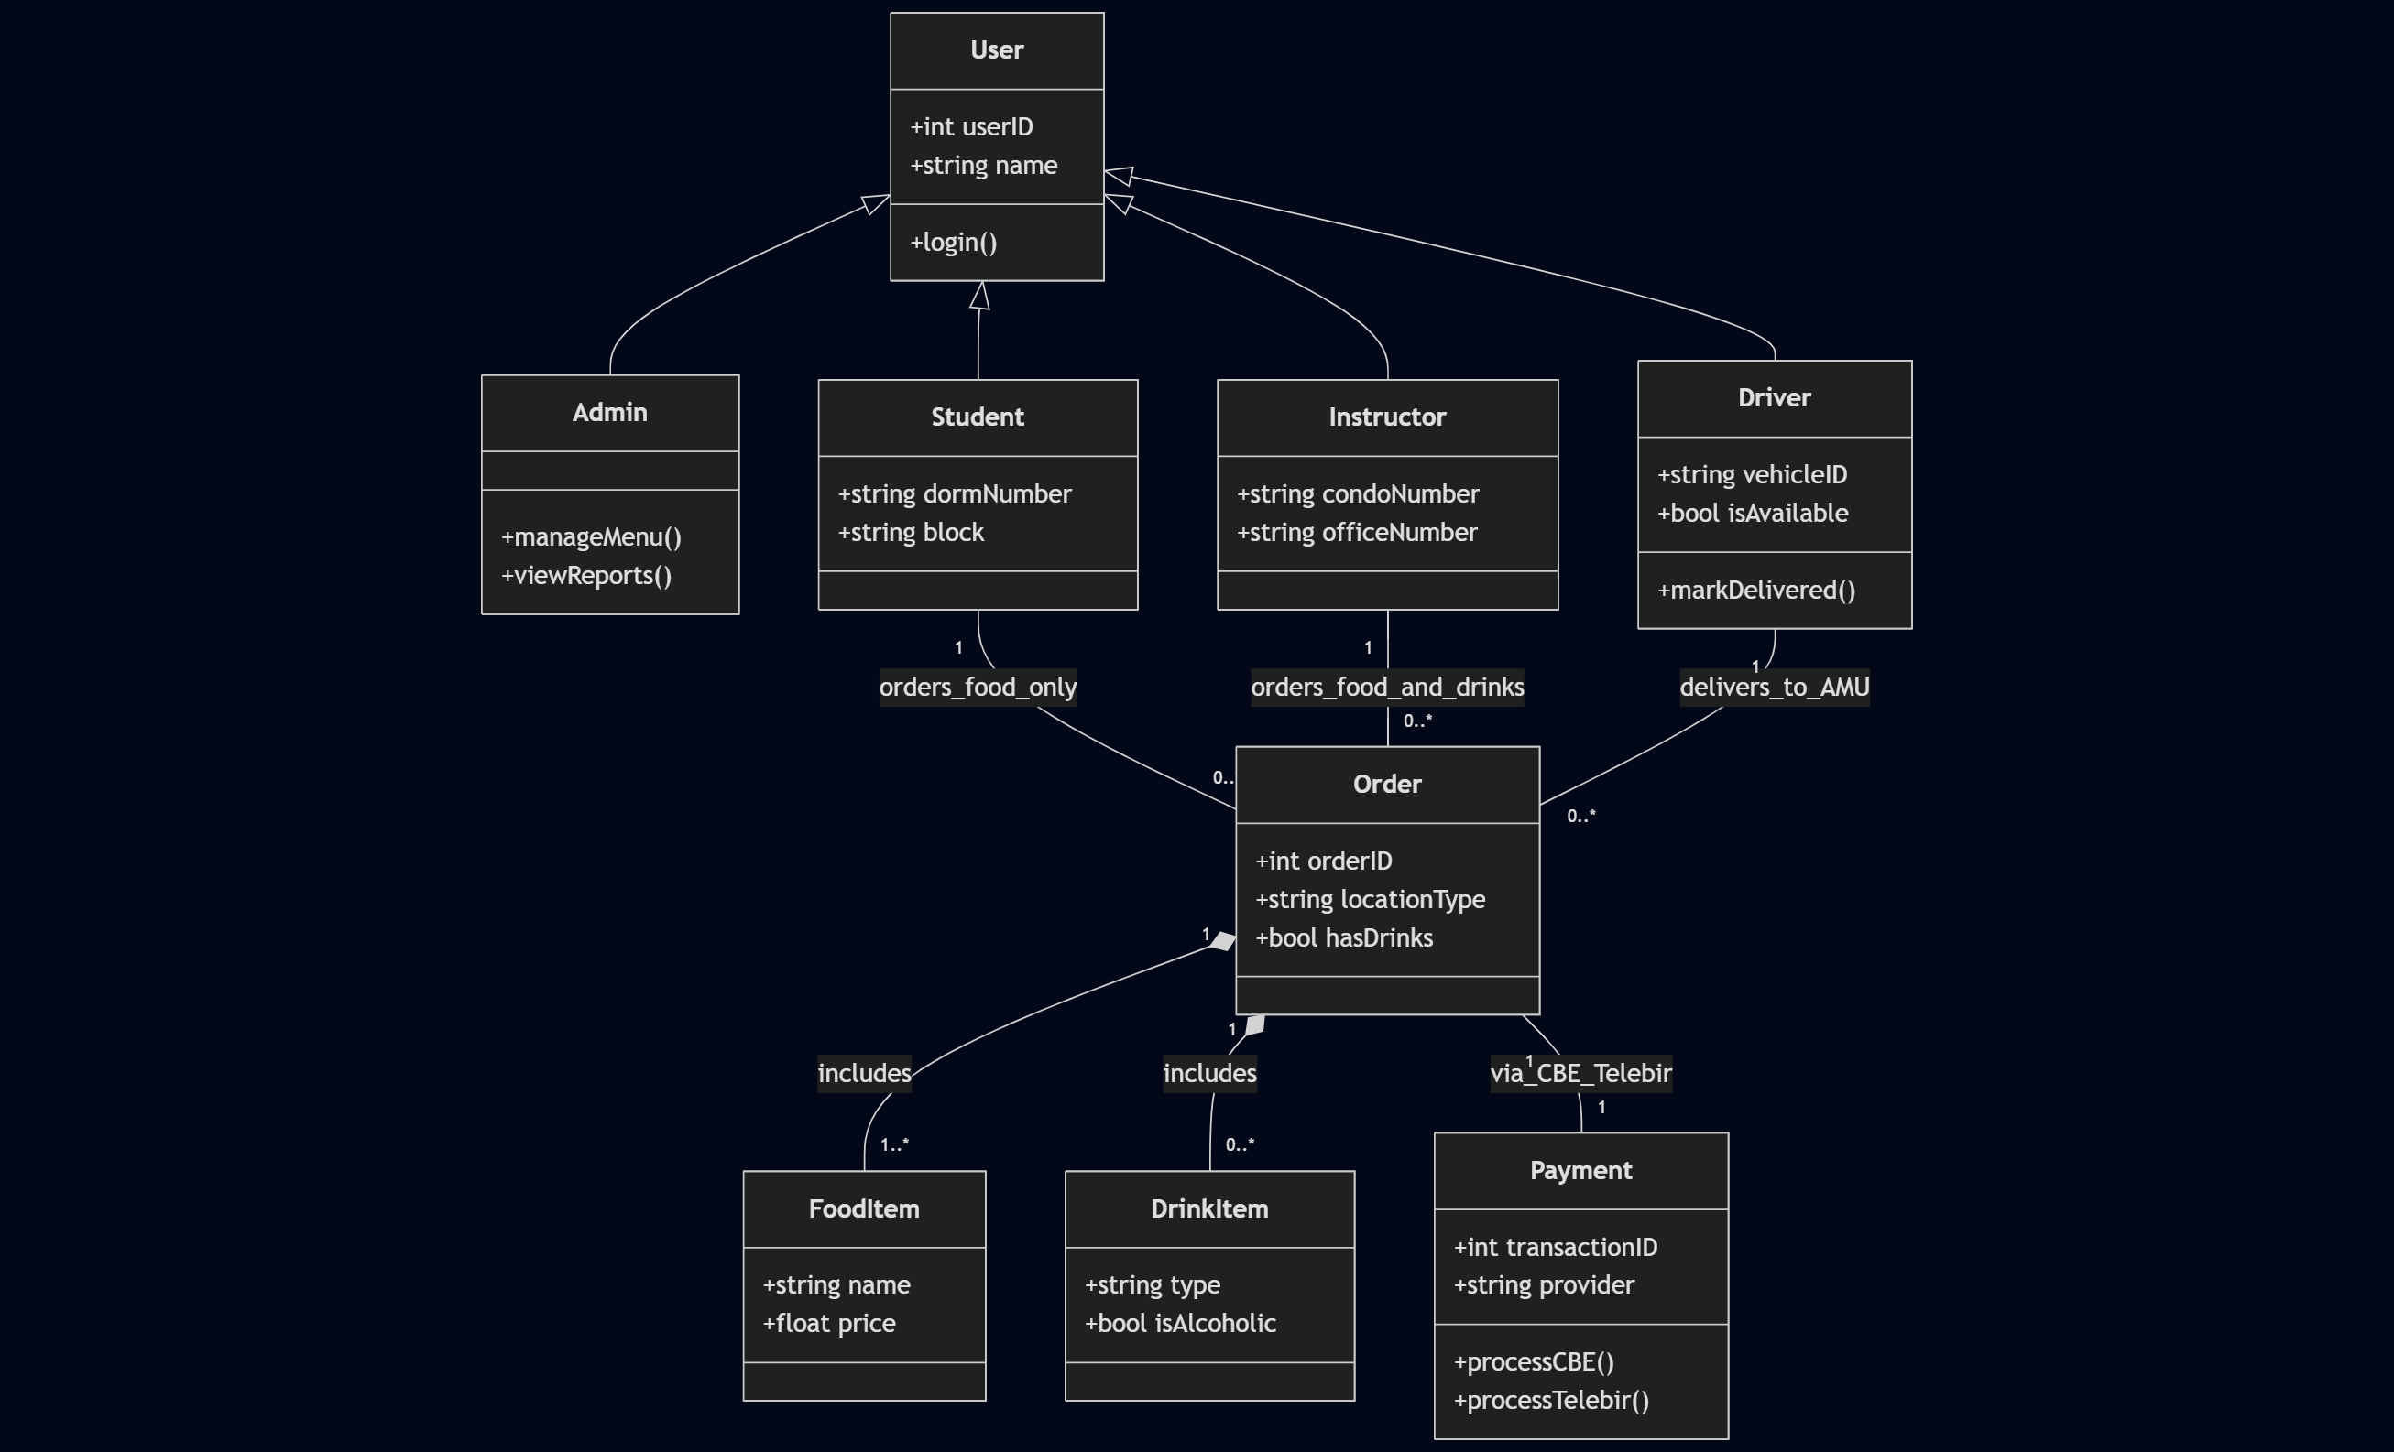

graph LR
%% --- ACTORS ---
S((Student))
I((Instructor))
A((Admin))
D((Driver))

subgraph "Lucy Cafe AMU Delivery System"
UC1(Browse Food Menu)
UC2(Order Food)
UC3(Order Drinks - Instructors Only)
UC4(Pay via CBE or Telebir)
UC5(Manage Inventory & Users)
UC6(Delivery to Dorm/Condo/Office)
end

%% --- CONNECTIONS ---
S --- UC1
S --- UC2
S --- UC4
S --- UC6

I --- UC1
I --- UC2
I --- UC3
I --- UC4
I --- UC6

D --- UC6
A --- UC5

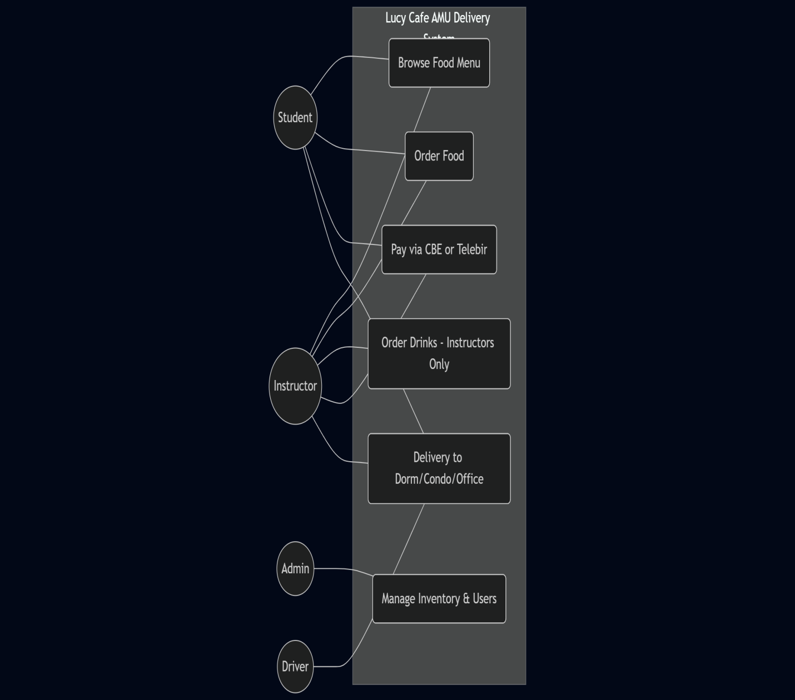

### 3. Order Lifecycle (State Diagram)
```mermaid
stateDiagram-v2
[*] --> Pending : Customer places order

state Payment_Branch <<choice>>
Pending --> Payment_Branch

Payment_Branch --> Cancelled : Payment Failed
Payment_Branch --> Paid : CBE/Telebir Success

Paid --> Preparing : Kitchen receives order
Preparing --> ReadyForPickup : Food/Drink is ready

ReadyForPickup --> OutForDelivery : Driver accepts

state OutForDelivery {
[*] --> AtAMUMainGate
AtAMUMainGate --> FindingLocation : Dorm/Condo/Office
}

OutForDelivery --> Delivered : Customer receives order
Delivered --> [*]
Cancelled --> [*]
```

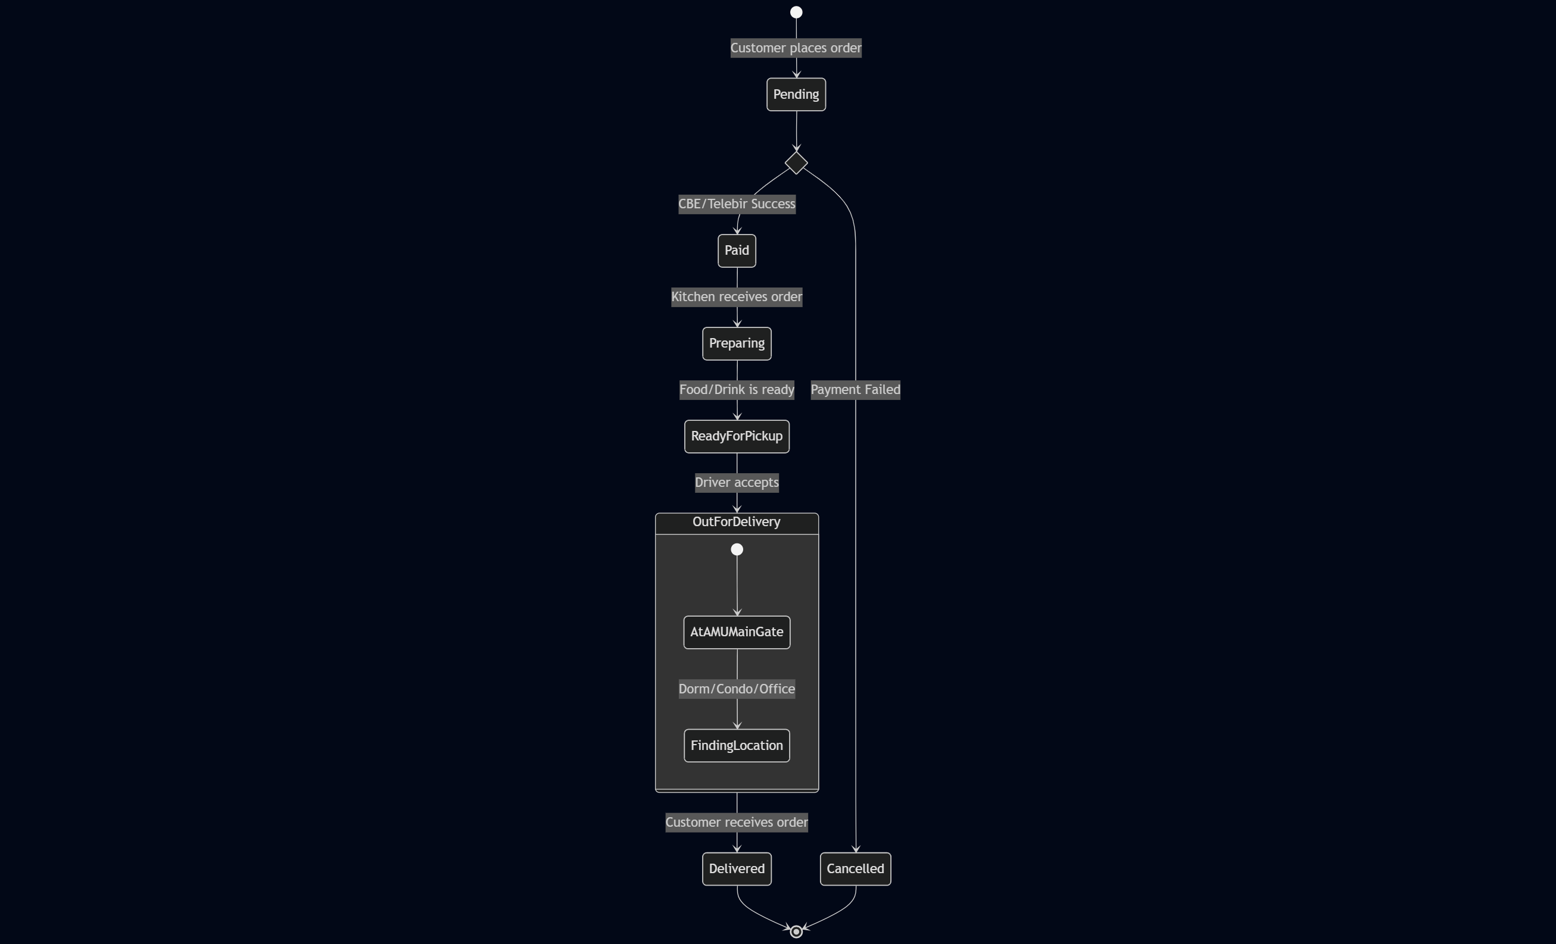

### 4. 🗄️ Database ER-D (SQL)
```mermaid
erDiagram
USERS ||--|| STUDENTS : "is a"
USERS ||--|| INSTRUCTORS : "is a"
USERS ||--o{ ORDERS : "places/delivers"
ORDERS ||--|| PAYMENTS : "has"
ORDERS }o--|{ MENU-ITEMS : "contains"

USERS {
int userID PK
string name
string email
string role
}
STUDENTS {
int userID PK, FK
string dormNumber
string block
}
INSTRUCTORS {
int userID PK, FK
string condoNumber
string officeNumber
}
ORDERS {
int orderID PK
int customerID FK
int driverID FK
string status
decimal totalAmount
}
PAYMENTS {
int paymentID PK
int orderID FK
string method
string status
}
MENU-ITEMS {
int itemID PK
string name
decimal price
bool isDrink
}
```
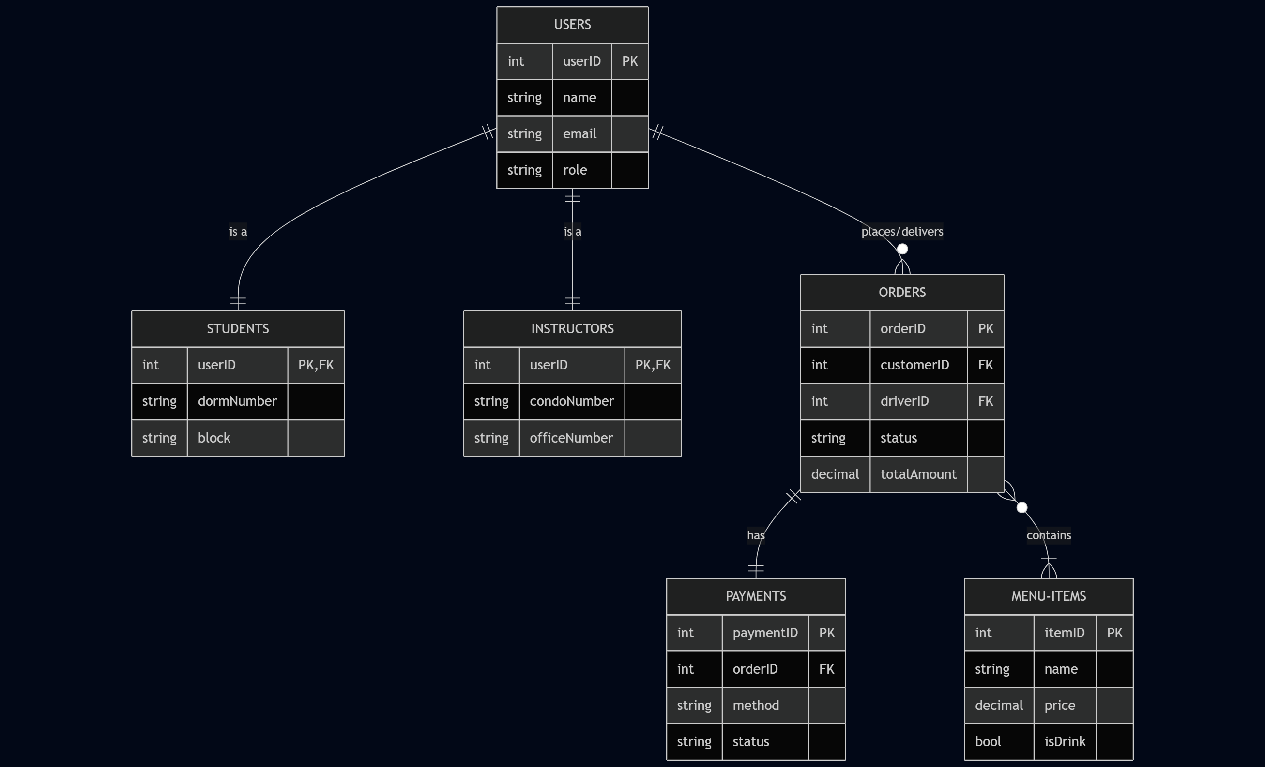

### 🗄️ Database Implementation (SQL)
```sql
-- 1. Users Table (Base for all roles)
CREATE TABLE Users (
userID INT PRIMARY KEY AUTO_INCREMENT,
name VARCHAR(100),
email VARCHAR(100) UNIQUE,
role ENUM('Admin', 'Student', 'Instructor', 'Driver')
);
-- 2. Specific Roles
CREATE TABLE Students (
userID INT PRIMARY KEY,
dormNumber VARCHAR(20),
block VARCHAR(10),
FOREIGN KEY (userID) REFERENCES Users(userID)
);
CREATE TABLE Instructors (
userID INT PRIMARY KEY,
condoNumber VARCHAR(20),
officeNumber VARCHAR(20),
FOREIGN KEY (userID) REFERENCES Users(userID)
);
-- 3. Menu Items (Food and Drinks)
CREATE TABLE MenuItems (
itemID INT PRIMARY KEY AUTO_INCREMENT,
name VARCHAR(100),
price DECIMAL(10, 2),
isDrink BOOLEAN
);
-- 4. Orders and Payments
CREATE TABLE Orders (
orderID INT PRIMARY KEY AUTO_INCREMENT,
customerID INT,
driverID INT,
status VARCHAR(50),
totalAmount DECIMAL(10, 2),
FOREIGN KEY (customerID) REFERENCES Users(userID),
FOREIGN KEY (driverID) REFERENCES Users(userID)
);
CREATE TABLE Payments (
paymentID INT PRIMARY KEY AUTO_INCREMENT,
orderID INT,
method ENUM('CBE', 'Telebirr'),
status VARCHAR(20),
FOREIGN KEY (orderID) REFERENCES Orders(orderID)
);

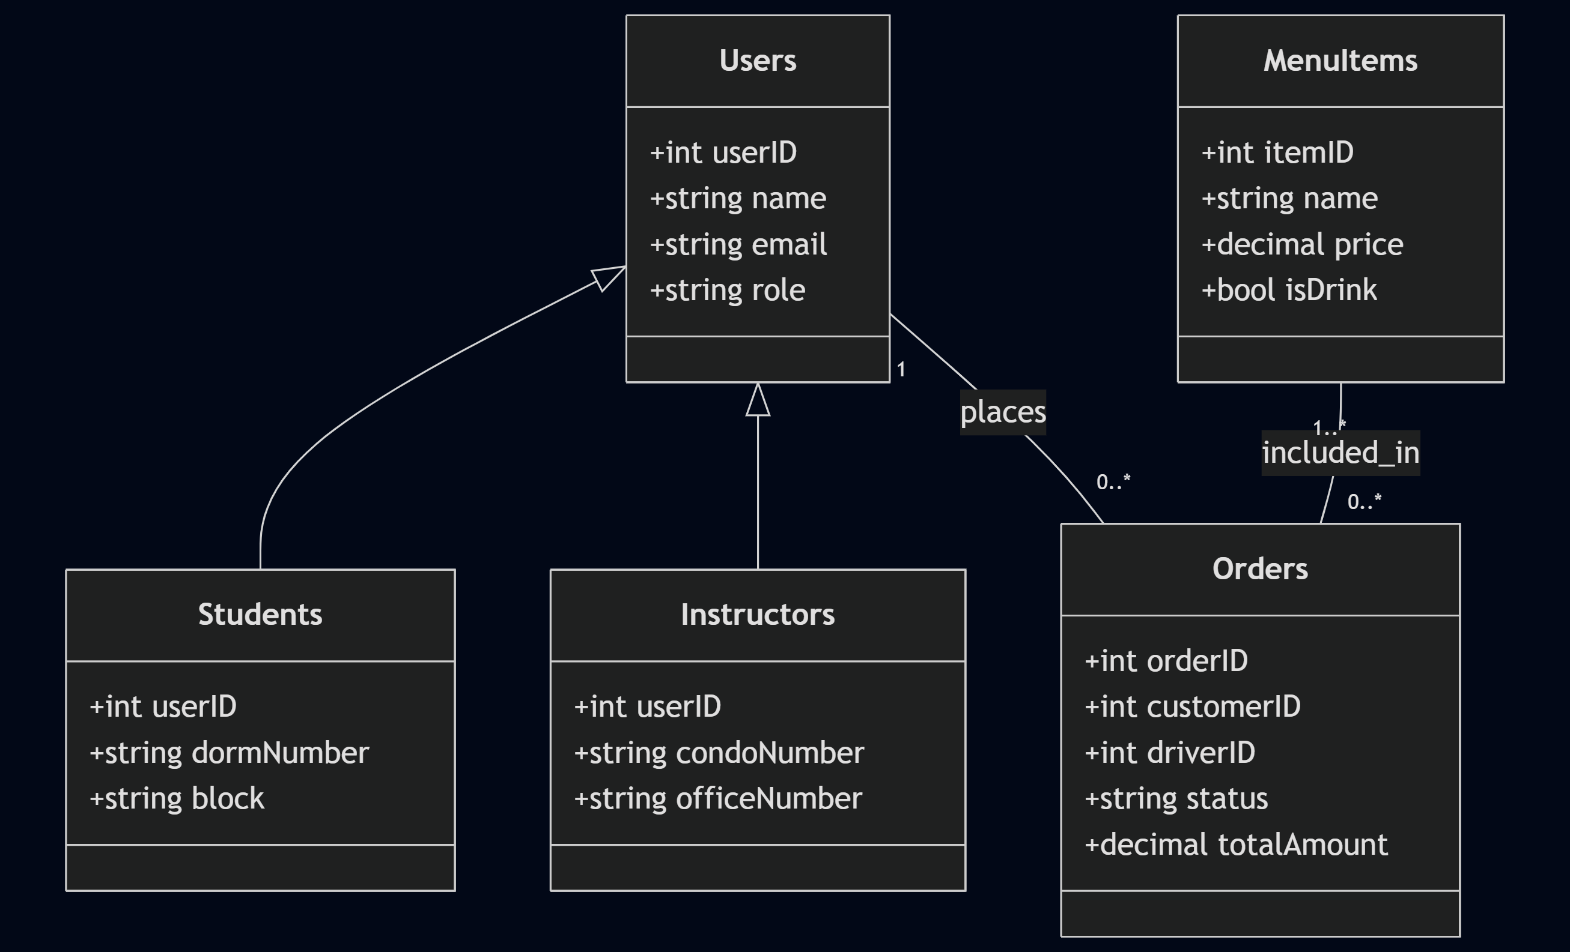

## 🚀 Getting Started
To implement this system, follow these steps:
1. **Database Setup**: Execute the SQL script provided in the [Database Schema](#database-schema-sql) section in your MySQL or PostgreSQL environment.
2. **Logic Implementation**: Use the **Class Diagram** as a guide for your backend models (Java/Python/C#).
3. **Frontend Flow**: Follow the **State Diagram** to ensure your application UI updates correctly as the order moves from 'Paid' to 'Delivered'.

---

## 🏁 Conclusion & Project Summary
The **Lucy Cafe AMU Delivery System** design demonstrates a complete Object-Oriented Analysis and Design (OOAD) approach. By moving through the following stages, the project ensures a robust and scalable solution:

1. **Requirement Mapping:** Use Case diagrams identified unique campus needs, such as location-based delivery (Dorms/Condos) and restricted item logic for Students vs. Instructors.
2. **Structural Integrity:** The Class Diagram established a clear inheritance hierarchy (`User` → `Student`/`Instructor`) and defined the relationships between core entities like `Orders` and `Payments`.
3. **Behavioral Modeling:** The State Diagram provided a roadmap for order tracking, specifically handling the digital payment flow via **CBE** and **Telebirr**.
4. **Database Readiness:** The SQL schema successfully translated abstract objects into a relational database structure, ready for implementation.

This documentation serves as a blueprint for developers to build a functional, secure, and campus-optimized food delivery application for Arba Minch University.

https://github.com/Eby-Ebisa/Lucy-Cafe-System-UML
mermaid.js

